Testing Brief

End-of-Course Tests
Winter 2006
November 27, 2006 – January 12, 2007

Georgia law (O.C.G.A. §20-2-281) states “the State Board of Education shall adopt end-of-course assessments for students in grades 9 through 12 for all core subjects to be determined by the state board.” The purpose of the End-of-Course Tests is to assess student achievement in the Quality Core Curriculum and Georgia Performance Standards in the designated eight core courses and to provide diagnostic data to improve student achievement. Definitions for student achievement as defined by Georgia teachers at the Meets Standard performance level and the Exceeds Standard performance level are outlined in the EOCT Interpretive Guide and on the Individual Student Report for each content area.

The EOCT assess only a sample of the knowledge and skills that educators agree comprise a complete curriculum for each subject. Georgia students have opportunities to learn – and are expected to master – much more than the tests address. The Georgia Quality Core Curriculum is the source of the knowledge and skills assessed on the Math and Social Studies tests. The Georgia Performance Standards are the source of the knowledge and skills assessed on the Science and Language Arts tests.

Key Findings – Language Arts

Ninth grade literature and composition
- A total of 32,604 students were assessed in Ninth Grade Literature and Composition.

- Sixty (60) percent of Georgia’s ninth grade students met or exceeded the standard for Ninth Grade Literature and Composition.

- The mean scale score for Ninth Grade Literature and Composition was 408.**

American Literature and Composition
- A total of 30,985 students were assessed in American Literature and Composition.

- Seventy-seven (77) percent of Georgia’s students met or exceeded the standard for American Literature and Composition.

- The mean scale score for American Literature and Composition was 421.**

Key Findings – Science

Biology

- A total of 34,665 students were assessed in Biology.

- Fifty-two (52) percent of Georgia’s students met or exceeded the standard for Biology.

- The mean scale score for Biology was 404.**

Physical Science

- A total of 27,453 students were assessed in Physical Science.

- Fifty-nine (59) percent of Georgia’s students met or exceeded the standard for Physical Science.

- The mean scale score for Physical Science was 409.**
** For Ninth grade Literature, American Literature, Biology and Physical Science, a scale score of 400 is necessary to meet standard. A scale score of 450 or higher is necessary to exceed standard. These tests were aligned with the Georgia Performance Standards, beginning with the 05/06 school year. With the transition from the Quality Core Curriculum (QCC) to the new Georgia Performance Standards (GPS), both the content and the performance standard for these tests changed. When this occurs, it is appropriate to establish a new scale to describe performance. It is important to note that the new GPS based EOCT are not comparable to previous QCC based tests.
Key Findings – Social Studies

U.S. History
- A total of 27,364 students were assessed in U.S. History

- Sixty-four (64) percent of Georgia’s students met or exceeded the standard for U.S. History.

- The mean scale score for U.S. History was 614.*

- This EOCT continues to be aligned with the Quality Core Curriculum.

Economics/Business/Free Enterprise
- A total of 45,035 students were assessed in Economics/Business/Free Enterprise.

- Fifty-nine (59) percent of Georgia’s students met or exceeded the standard for Economics/Business/Free Enterprise.

- The mean scale score for Economics/Business/Free Enterprise was 616.*

- This EOCT continues to be aligned with the Quality Core Curriculum.

Key Findings – Mathematics

Algebra I
- A total of 19,968 students were assessed in Algebra I.

- Fifty-six (56) percent of Georgia’s students met or exceeded the standard for Algebra I.

- The mean scale score for Algebra I was 607.*

- This EOCT continues to be aligned with the Quality Core Curriculum.

Geometry
- A total of 23,814 students were assessed in Geometry.

- Sixty-three (63) percent of Georgia’s students met or exceed the standard for Geometry.

- The mean scale score for Geometry was 612.*

- This EOCT continues to be aligned with the Quality Core Curriculum.

* For U.S. History, Economics, Algebra and Geometry, a scale score of 600 is necessary to meet standard. A scale score of 630 or higher demonstrates a performance level of exceeds standard.

Percent in Performance Level - Georgia EOCT – Winter 2006

Performance Level | Ninth Grade Literature and Composition | American Literature and Composition | Biology | Physical Science | U.S. History | Economics | Algebra I | Geometry
Exceeds Standard | 14 | 18 | 11 | 19 | 31 | 40 | 24 | 23
Meets Standard | 47 | 59 | 41 | 40 | 33 | 19 | 31 | 40
Does Not Meet | 40 | 23 | 48 | 41 | 36 | 41 | 44 | 37

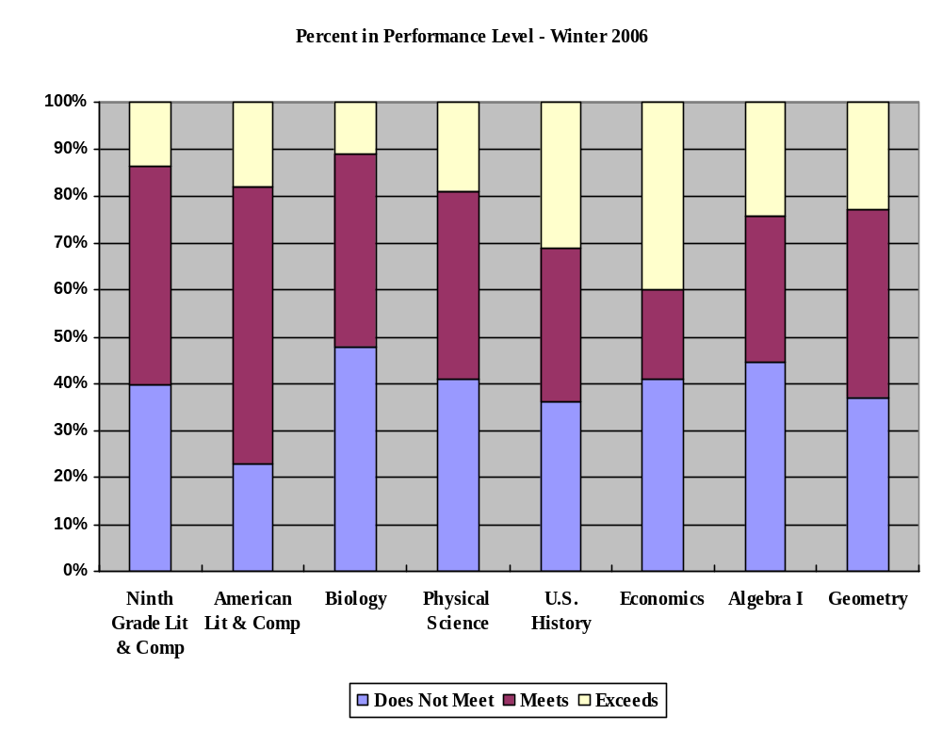

Historical Performance of Students on the Georgia EOCT

 | Percent of Students Meeting and Exceeding Standard on EOCT
 | Winter 2005 | Spring 2006 | Winter 2006
Ninth Grade Literature | 60 | 66 | 60
American Literature | 77 | 82 | 77
Biology | 50 | 59 | 52
Physical Science | 54 | 62 | 59
U.S. History | 67 | 72 | 64
Economics | 55 | 62 | 59
Algebra I | 57 | 65 | 56
Geometry | 59 | 63 | 63

EOCT Historical Comparisons
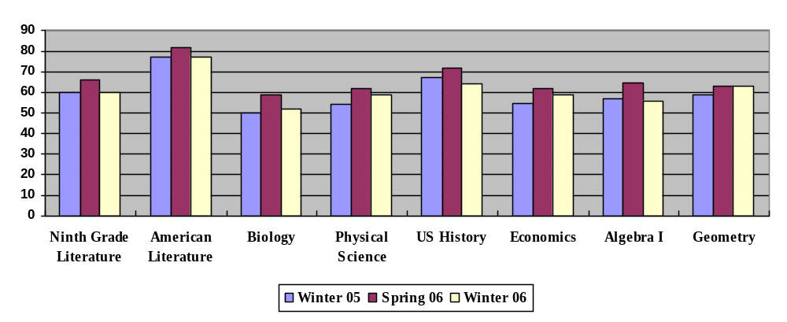

Historical Performance by Subject on the Georgia EOCT

Ninth Grade Literature and Composition |  |  |  |  | 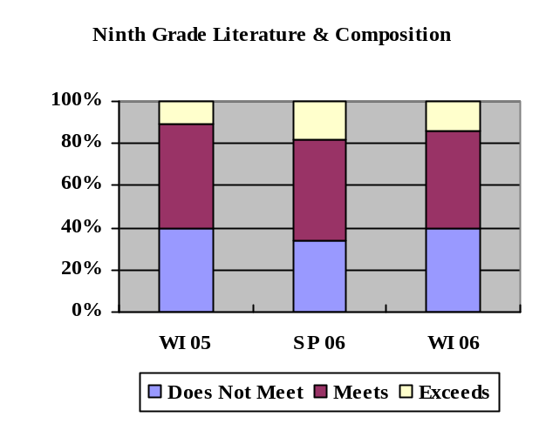
Performance Level | Percent of Students
Performance Level | WI 05 | SP 06 | WI 06
Exceeds | 11 | 18 | 14
Meets | 49 | 48 | 47
Does Not Meet | 40 | 34 | 40

American Literature and Composition |  |  |  |  | 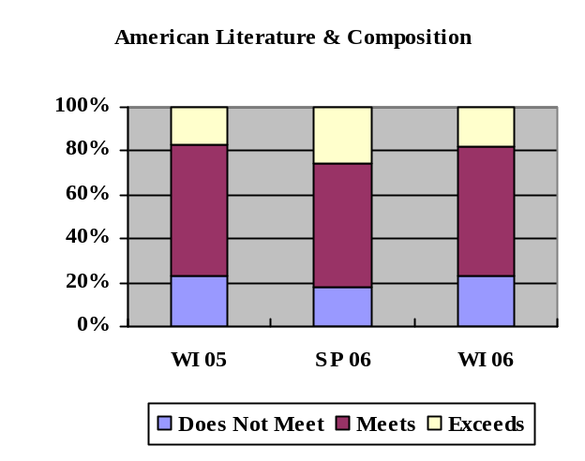
Performance Level | Percent of Students
Performance Level | WI 05 | SP 06 | WI 06
Exceeds | 17 | 26 | 18
Meets | 60 | 56 | 59
Does Not Meet | 23 | 18 | 23

Historical Performance by Subject on the Georgia EOCT

Biology |  |  |  |  | 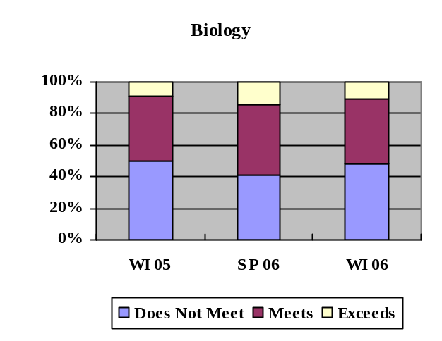
Performance Level | Percent of Students
Performance Level | WI 05 | SP 06 | WI 06
Exceeds | 9 | 14 | 11
Meets | 41 | 45 | 41
Does Not Meet | 50 | 41 | 48

Physical Science |  |  |  |  | 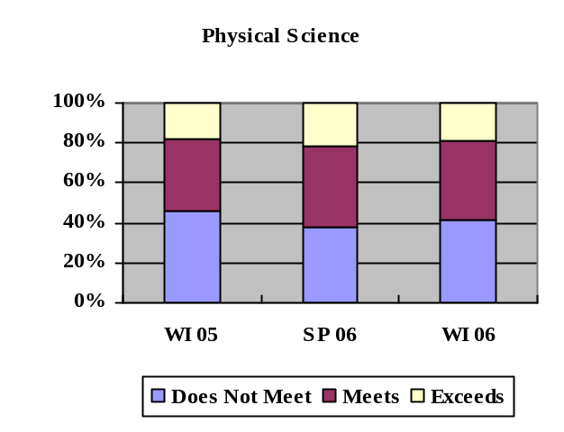
Performance Level | Percent of Students
Performance Level | WI 05 | SP 06 | WI 06
Exceeds | 18 | 22 | 19
Meets | 37 | 40 | 40
Does Not Meet | 46 | 38 | 41

Historical Performance by Subject on the Georgia EOCT

U.S. History |  |  |  |  | 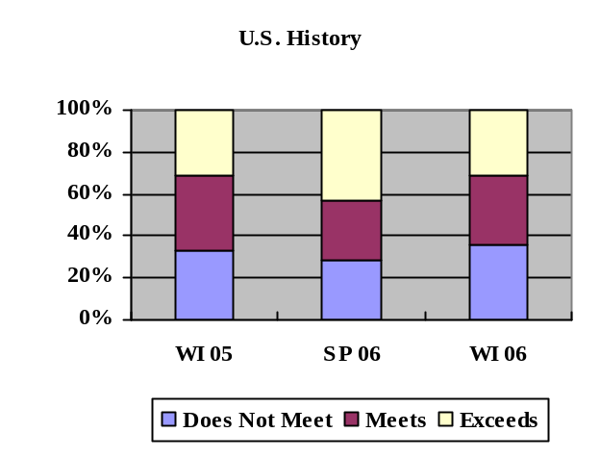
Performance Level | Percent of Students
Performance Level | WI 05 | SP 06 | WI 06
Exceeds | 31 | 43 | 31
Meets | 35 | 29 | 33
Does Not Meet | 33 | 28 | 36

Economics |  |  |  |  | 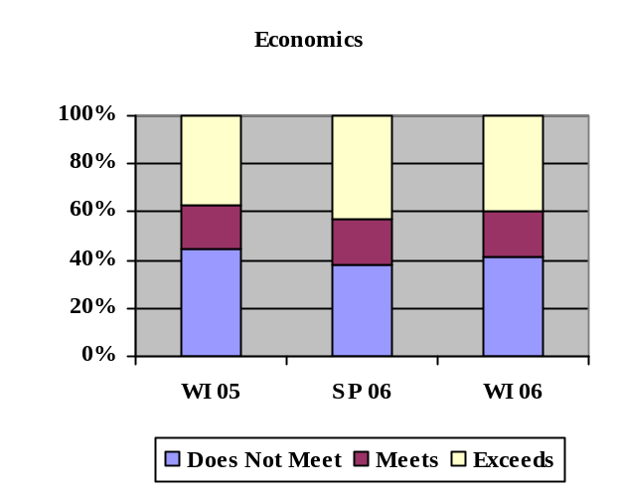
Performance Level | Percent of Students
Performance Level | WI  05 | SP 06 | WI 06
Exceeds | 37 | 43 | 40
Meets | 18 | 19 | 19
Does Not Meet | 45 | 38 | 41

Historical Performance by Subject on the Georgia EOCT

Algebra I |  |  |  |  | 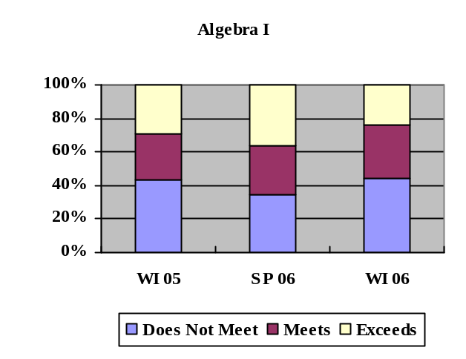
Performance Level | Percent of Students
Performance Level | WI  05 | SP 06 | WI 06
Exceeds | 29 | 37 | 24
Meets | 28 | 29 | 31
Does Not Meet | 43 | 35 | 44

Geometry |  |  |  |  | 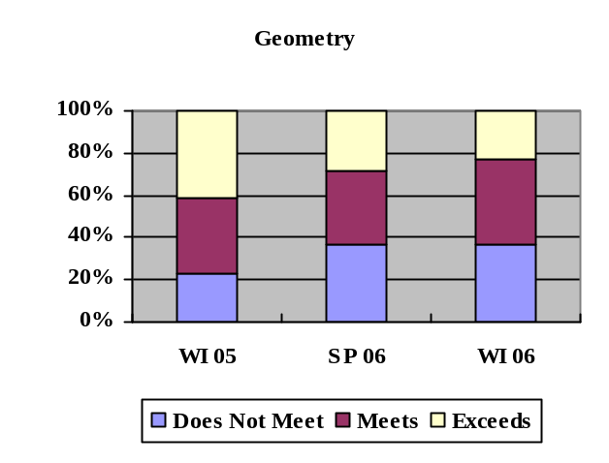
Performance Level | Percent of Students
Performance Level | WI  05 | SP 06 | WI 06
Exceeds | 23 | 28 | 23
Meets | 36 | 35 | 40
Does Not Meet | 41 | 37 | 37

Historical Performance of Sub-Groups on the Georgia EOCT

(Because of rounding, all disaggregated charts may not appear consistent with historical data.)

Ninth Grade Literature  & Composition | Percent of Students Meeting and Exceeding Standard
 | Winter 2005 | Spring 2006 | Winter 2006 | Change from WI 05 to WI 06
All Students | 60 | 66 | 60 | -0-
English Language Learners | 19 | 15 | 19 | -0-
Students with Disabilities | 20 | 25 | 22 | +2
Asian | 72 | 83 | 72 | -0-
Black | 45 | 50 | 45 | -0-
Hispanic | 48 | 53 | 49 | +1
Native American/Alaskan | 42 | 62 | 53 | +11
White | 73 | 79 | 74 | +1
Multiracial | 64 | 72 | 69 | +5

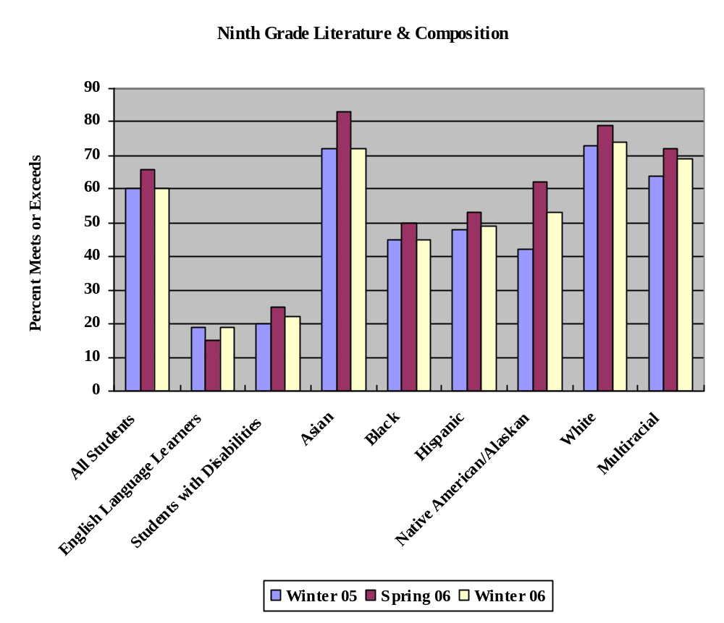
Historical Performance of Sub-Groups on the Georgia EOCT

American Literature  & Composition | Percent of Students Meeting and Exceeding Standard
 | Winter 2005 | Spring 2006 | Winter 2006 | Change from WI 05 to WI 06
All Students | 77 | 82 | 77 | -0-
English Language Learners | 32 | 38 | 34 | +2
Students with Disabilities | 33 | 40 | 36 | +3
Asian | 83 | 88 | 87 | +4
Black | 65 | 71 | 66 | +1
Hispanic | 66 | 71 | 68 | +2
Native American/Alaskan | 77 | 84 | 83 | +6
White | 86 | 90 | 87 | +1
Multiracial | 80 | 87 | 81 | +1

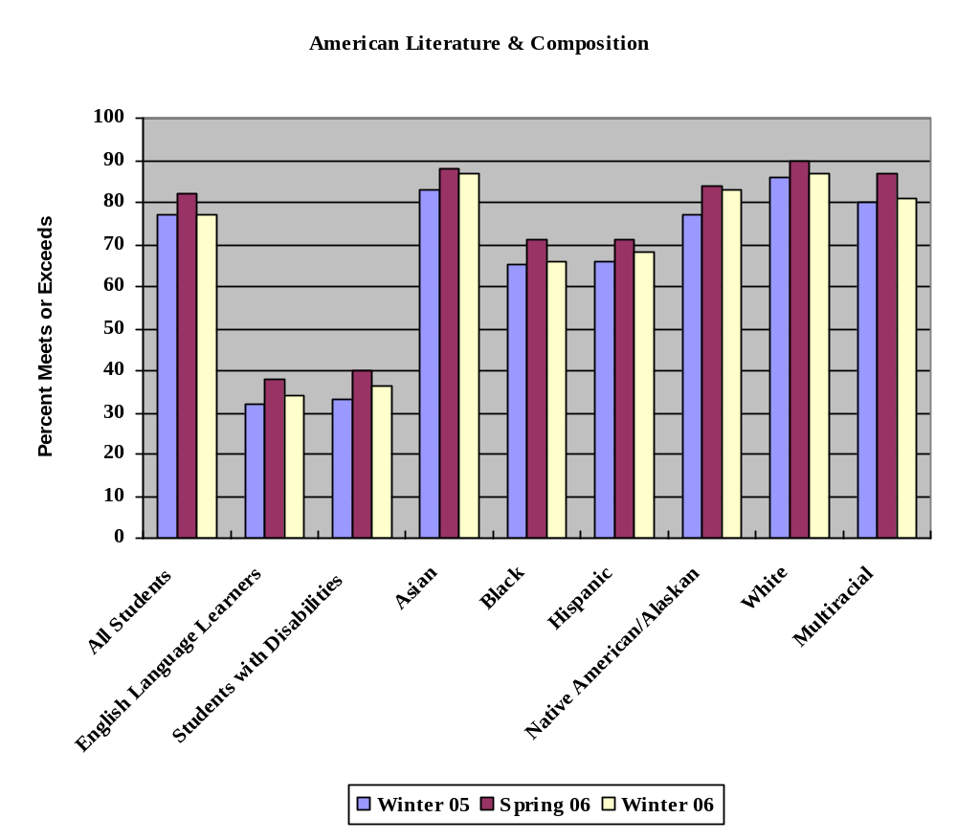

Historical Performance of Sub-Groups on the Georgia EOCT

Biology | Percent of Students Meeting and Exceeding Standard
 | Winter 2005 | Spring 2006 | Winter 2006 | Change from WI 05 to WI 06
All Students | 50 | 59 | 52 | +2
English Language Learners | 14 | 21 | 14 | -0-
Students with Disabilities | 19 | 27 | 22 | +3
Asian | 63 | 76 | 67 | +4
Black | 31 | 41 | 34 | +3
Hispanic | 36 | 45 | 39 | +3
Native American/Alaskan | 38 | 60 | 47 | +9
White | 68 | 76 | 70 | +2
Multiracial | 52 | 64 | 56 | +4

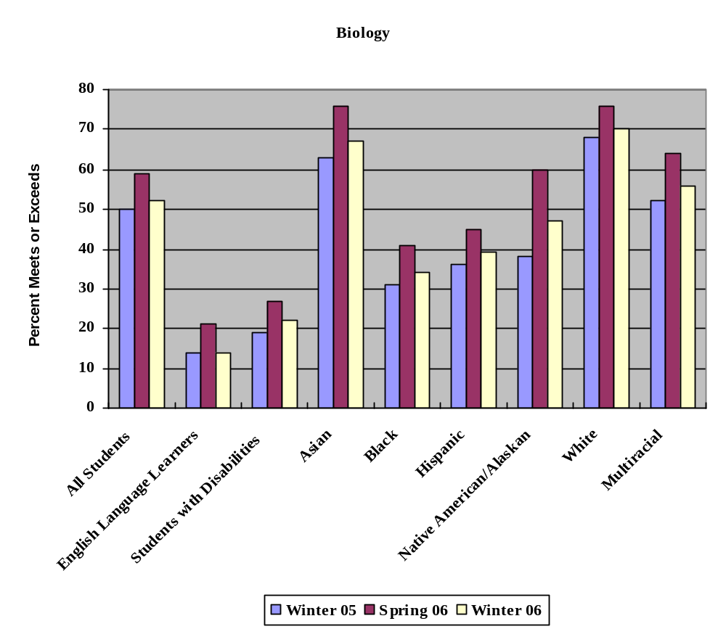

Historical Performance of Sub-Groups on the Georgia EOCT

Physical Science | Percent of Students Meeting and Exceeding Standard
 | Winter 2005 | Spring 2006 | Winter 2006 | Change from WI 05 to WI 06
All Students | 54 | 62 | 59 | +5
English Language Learners | 20 | 29 | 34 | +14
Students with Disabilities | 24 | 29 | 30 | +6
Asian | 69 | 76 | 70 | +1
Black | 40 | 48 | 44 | +4
Hispanic | 43 | 52 | 56 | +13
Native American/Alaskan | 44 | 62 | 57 | +13
White | 69 | 75 | 72 | +3
Multiracial | 55 | 65 | 66 | +11

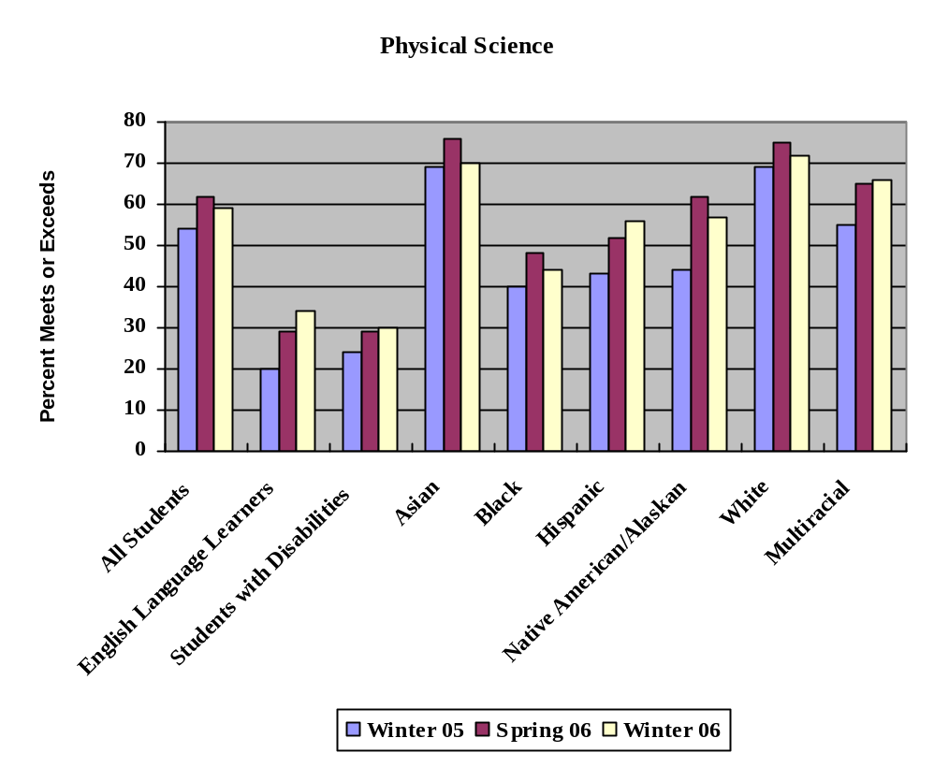

Historical Performance of Sub-Groups on the Georgia EOCT

U.S. History | Percent of Students Meeting and Exceeding Standard
 | Winter 05 | Spring 06 | Winter 06 | Change from WI 05 to WI 06
All Students | 67 | 72 | 64 | -3
English Language Learners | 31 | 37 | 28 | -3
Students with Disabilities | 35 | 38 | 36 | +1
Asian | 79 | 86 | 74 | -5
Black | 53 | 57 | 48 | -5
Hispanic | 57 | 61 | 55 | -2
Native American/Alaskan | 58 | 76 | 65 | +7
White | 77 | 83 | 77 | -0-
Multiracial | 73 | 75 | 67 | -6

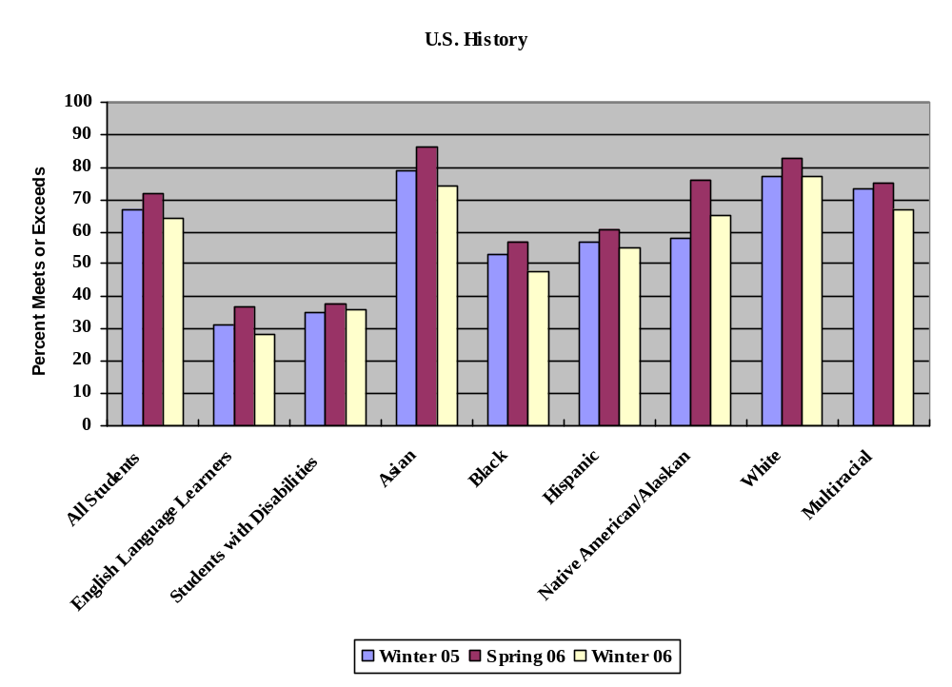

Historical Performance of Sub-Groups on the Georgia EOCT

Economics | Percent of Students Meeting and Exceeding Standard
 | Winter 05 | Spring 06 | Winter 06 | Change from WI 05 to WI 06
All Students | 55 | 62 | 59 | +4
English Language Learners | 18 | 16 | 26 | +8
Students with Disabilities | 23 | 27 | 27 | +4
Asian | 71 | 80 | 77 | +6
Black | 37 | 40 | 40 | +3
Hispanic | 45 | 49 | 48 | +3
Native American/Alaskan | 57 | 75 | 61 | +4
White | 69 | 76 | 73 | +4
Multiracial | 56 | 66 | 60 | +4

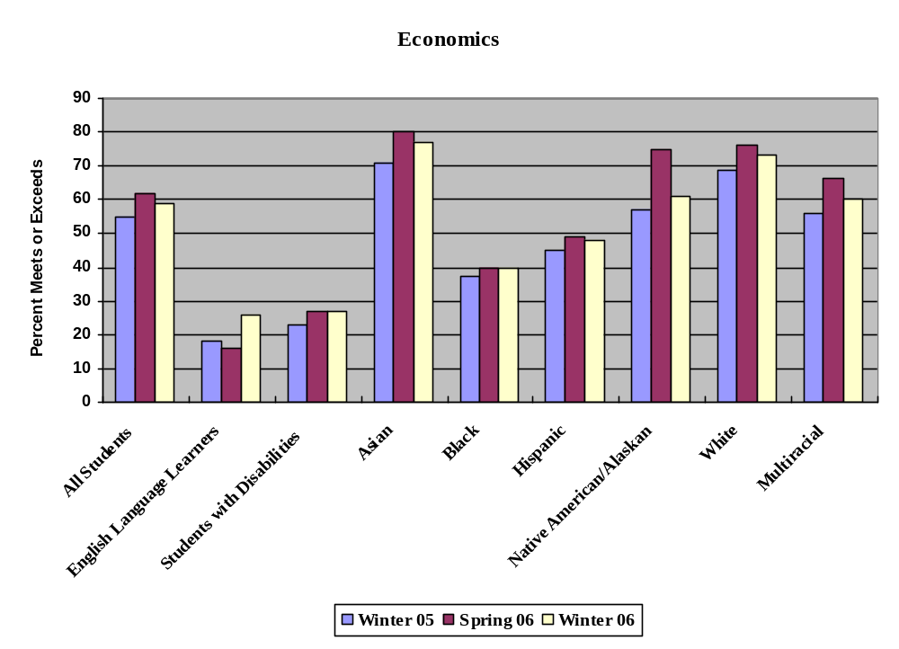

Historical Performance of Sub-Groups on the Georgia EOCT

Algebra I | Percent of Students Meeting and Exceeding Standard
 | Winter 05 | Spring 06 | Winter 06 | Change from WI 05 to WI 06
All Students | 57 | 65 | 56 | -1
English Language Learners | 39 | 44 | 44 | +5
Students with Disabilities | 23 | 33 | 26 | +3
Asian | 71 | 86 | 70 | -1
Black | 41 | 47 | 40 | -1
Hispanic | 52 | 58 | 53 | +1
Native American/Alaskan | 52 | 63 | 64 | +12
White | 71 | 80 | 69 | -2
Multiracial | 58 | 69 | 61 | +3

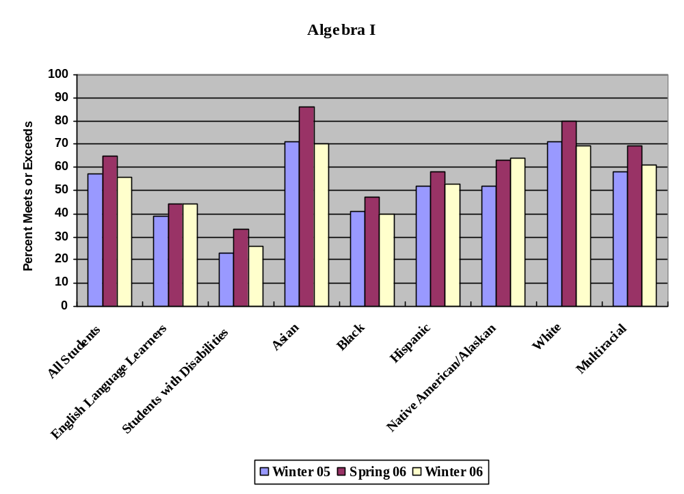

Historical Performance of Sub-Groups on the Georgia EOCT

Geometry | Percent of Students Meeting and Exceeding Standard
 | Winter 05 | Spring 06 | Winter 06 | Change from WI 05 to WI 06
All Students | 59 | 63 | 63 | +4
English Language Learners | 46 | 50 | 46 | -0-
Students with Disabilities | 27 | 32 | 34 | +7
Asian | 76 | 84 | 82 | +6
Black | 37 | 40 | 42 | +5
Hispanic | 52 | 58 | 58 | +6
Native American/Alaskan | 50 | 68 | 67 | +17
White | 78 | 80 | 78 | -0-
Multiracial | 59 | 63 | 65 | +6

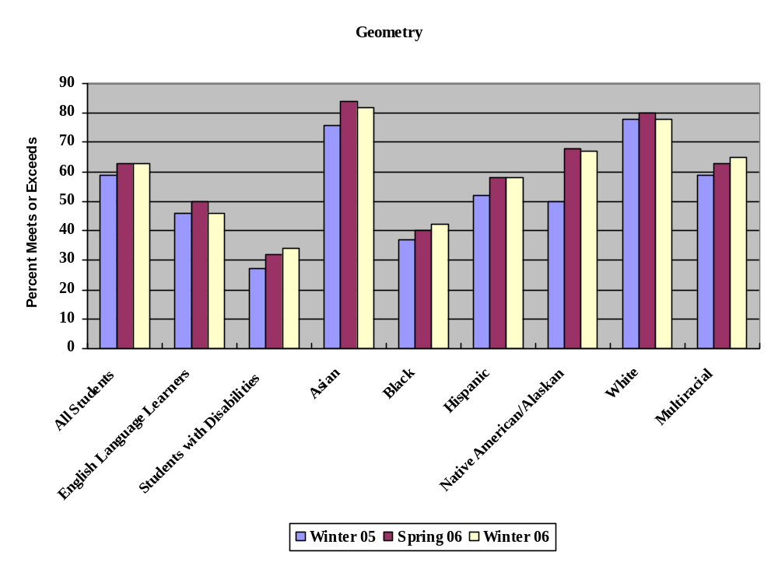

Number of tests administered

Spring 06* | Total tests | Electronic /  69 systems
9th Literature & Comp. | 95,409 | 6,341
American Literature | 74,623 | 14,042
Algebra I | 122,713 | 10,699
Geometry | 73,224 | 6,558
U.S. History | 78,278 | 14,529
Economics | 40,637 | 15,810
Physical Science | 66,827 | 5,574
Biology | 90,880 | 16,267
TOTAL | 642,591 | 89,820
* Figures include Jan., Feb., and Mar online mid-month administrations

Winter 06* | Total tests | Electronic /  66 systems
9th Literature & Comp. | 32,604 | 3,897
American Literature | 30,985 | 5,195
Algebra I | 19,968 | 3,377
Geometry | 23,814 | 4,186
U.S. History | 27,364 | 4,342
Economics | 45,035 | 12,340
Physical Science | 27,453 | 3,016
Biology | 34,665 | 5,737
TOTAL | 241,888 | 42,090
* Figures include Aug., Sept, Oct., and Nov. online mid-month administrations

Mid-Month Electronic | Aug. 06 | Sept. 06 | Oct. 06 | Nov. 06 | Mid-Month Totals
9th Literature & Comp | 216 | 149 | 158 | 140 | 663
American Literature | 115 | 200 | 162 | 132 | 609
Algebra I | 227 | 262 | 139 | 84 | 712
Geometry | 140 | 191 | 87 | 46 | 464
U.S. History | 124 | 149 | 159 | 92 | 524
Economics | 44 | 143 | 3692 | 304 | 4183
Physical Science | 153 | 193 | 101 | 87 | 534
Biology | 166 | 213 | 158 | 81 | 618
Totals | 1185 | 1500 | 4656 | 966 | 8307

